North American Society for Trenchless Technology (NASTT)
2025 No-Dig Show
Denver, Colorado
March 30-April 3, 2025
MM-T1-01
No-Dig Show Trenchless Paper Tutorial and Template
Robert R. Robertson, PE, Engineering Company, Somewhere, Utah
John J. Johnson, Contractor, Anywhere, Ohio
- Abstract
This is a template document for preparing a paper for the No-Dig Show. This document contains styles to help format the paper and maintain a similar look and feel as other papers in the conference. This template in not intended to be comprehensive but should provide the tools to format a paper consistent with the NASTT standards.
To make better use of the styles embedded in this template, it is helpful to view them by turning on the Styles Viewer. There are a few ways to do this, but the best way is likely to embed the Text Styles shortcut in the Quick Access Toolbar. This way you can turn the style viewer on or off with a single click.
When the Text Styles shortcut is active, click on the icon above the ribbon and the styles pane will open. You can attach the styles pane to the document by dragging it to the side of the document or leave it floating if it’s not in the way.
- Heading Level 1 - Styles
The heading above this text is preformatted with the No-Dig – Heading 1 – Numbered heading style. With the Styles Pane active, by clicking the heading text above, the style in use will have a blue box around it. This indicates that the text is formatted with that style. Heading level 1 is used for main points of the paper. The No-Dig styles includes heading style levels 1 through 4 with built-in numbering.
The heading styles, title, paper name and other headings are in the Calibri font, which is a sans serif font. The body text, table text, and figure and table captions use Times New Roman, a serif font. This is the common usage in technical papers to aid in readability and clarity.
  - Heading Level 2 – Navigation Pane
The above text is formatted as a No-Dig – Heading 2 – Numbered heading. It is automatically formatted with a 2.1 number because it falls under the 2.0 Heading 1. You can see the hierarchy of the numbering system by activating the Navigation Pane. This can be done by adding the shortcut to the Quick Access Toolbar or by clicking the Navigation Pane checkbox in the ribbon under the View menu. When the navigation pane is active, you can see the hierarchy of the headings.
    - Heading Level 3 – Changing Heading Styles
The heading above is formatted with a level 3 heading, called No-Dig – Heading 3 – Numbered. If you need this to be another heading, select the text of the heading and then click on the desired heading in the styles pane. This will change the style and the indent of the heading in the navigation pane.
      - Heading Level 4 – Formatting Body Text
The majority of the paper should be formatted using the recommended No-Dig body text. Technical papers are most commonly formatted with a serif font. No-Dig uses Times New Roman 12 point as the standard body text. The paragraph style for body text includes paragraph spacing so there is no need to double return between paragraphs.
  - Heading Level 2 – Lists
In technical papers it is common practice to use numbered lists instead of bulleted lists. The No-Dig numbered list is a style you can use for most lists. To use it, type in some text in the body, select the text and then click on the No-Dig – List 1 style in the styles pane and it will turn to a list like the example below.
- Example List Text Item 1
- Item 2
  - Indented item level 2
- Item 3
When typing a list, you can indent to the second letter alpha list by hitting the Tab button. If you want to go up a level from the alpha second level to the numeric first level, hit the Shift and then Tab buttons.
- Equations, Tables, Graphs, Photos, and Illustrations
  - Heading Level 2 - Equations
To insert an equation, navigate to the Insert menu and then click on Equation. You can pick from several canned equations or start a new equation from scratch. When you’ve created the equation, it will insert it as an object in line with the text, see Equation 1. Be sure to put in the equation number, right justified with brackets to be consistent.
$P_{max}=u+\left(σ_{0}^{'}∙\left(1+\sin{ϕ}\right)+c∙\cos{ϕ}+c∙\cot{ϕ}\right)∙{\left(\left(({\frac{R_{0}}{R_{pmax}})}^{2}\right)+\left(\frac{σ_{0}^{'}∙\sin{ϕ}+c∙\cos{ϕ}}{G}\right)\right)}^{\frac{-\sin{ϕ}}{1+\sin{ϕ}}}-c∙\cot{ϕ}$ [1]
Where:
P_{max} | Formation Limit Pressure (pounds per square foot, psf)
μ | Pore water pressure (psf)
φ | Angle of internal friction of soil (degrees)
c | Cohesion (psf)
G | Shear Modulus (psf)
R_{o} | Radius of drilled hole (feet)
R_{pmax} | Maximum radius of elastic deformation of drilled hole (feet)
It is important to also define the variables for the reader. It is possible to just type in the variables in a list, but the formatting could be changed accidentally. It’s a little more complex but creating a table with transparent lines will look more uniform.
  - Heading Level 2 - Tables
Tables should be consistent throughout the paper text. Adding some color shading can help bring attention to important portions of the table, but a simple black and white table is more common, see Table 1. The table heading text and table body text are also set up as styles for consistency. Be sure to make sure you don’t change the font, formatting, or text from the set styles. If they do get changed, you can always select the text and reformat using the style pane. The table caption is also set up as a style for consistency.
Table 1. Soil Properties of Clay Profile
Soil | Unit Weight (kg/m³) | Unit Weight (pcf) | Cohesion (KPa) | Cohesion (psf) | Friction Angle (Degrees)
Stiff Clay | 110 | 1,760 | 1,000 | 48 | 0
Dense Sand | 125 | 2,000 | 0 | 0 | 32
Very Stiff Clay | 125 | 2,000 | 2,000 | 96 | 0
  - Heading Level 2 – Figures, Graphs, Photos, and Illustrations
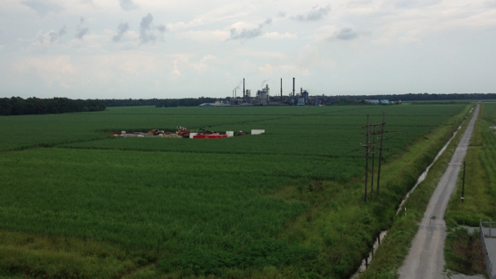
Figures, graphs, photos, and illustrations (figures) should be formatted consistently with a grouped caption that moves with the figure. Figures that are full width should be formatted with Top and Bottom layout in the Text Wrap button in the Picture Format ribbon. This ribbon only appears when a figure is selected.
Figure 1. Small Figure with Flow Around Text Wrapping

If the figure is not full-width and you want the text to flow around the figure, select the Tight or Square layout in the Text Wrap button in the Picture Format ribbon. Adjust the distance to text buffer in the More Layout Options in the Text Wrap button so the text flows properly.
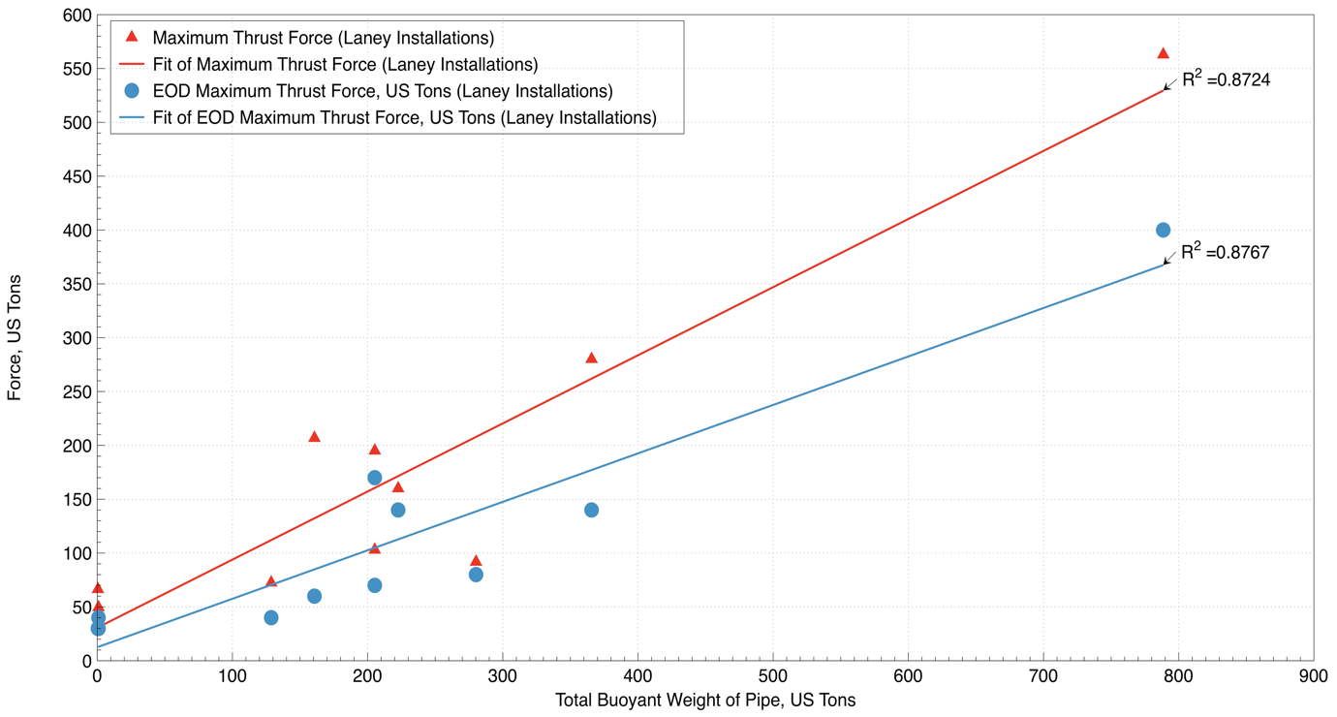
Figure 2. Large Full-Width Figure with Top and Bottom Text Wrapping

- Heading Level 1 - conclusions
The purpose of this new paper template is to introduce some uniformity and consistency in No-Dig papers. This is done by adding text styles to the typical formats used in papers. Some adjustments to these are allowed as long as the overall look and feel of the paper is consistent with these built-in styles.
- References
Bennett, D., Wallin, K., (2008). Step-by-Step Evaluation of Hydrofracture Risks for HDD Projects, North American Society for Trenchless Technology (NASTT), 2008 No-Dig Conference, Dallas, Texas
Bourgoyne, A.T., et al. (1991), “Applied Drilling Engineering,” Society of Petroleum Engineers.
Sparks, A.E. et al. (2010). Targeted HDD Design under Critical Structures to Reduce the Potential for Hydraulic Fracture, ASCE Pipelines Conference 2010, Keystone, Colorado.
Staheli, et al., (1998), Installation of Pipelines Beneath Levees Using Horizontal Directional Drilling, U.S. Army Corps of Engineers, Waterways Experiment Station, CPAR-98-1.
United States Army Corps of Engineers, (2012). CELMN-ED-F, Guidelines for Permit Review, Installing Pipelines by Nearsurface Directional Drilling Under Levees, updated July 2012.

