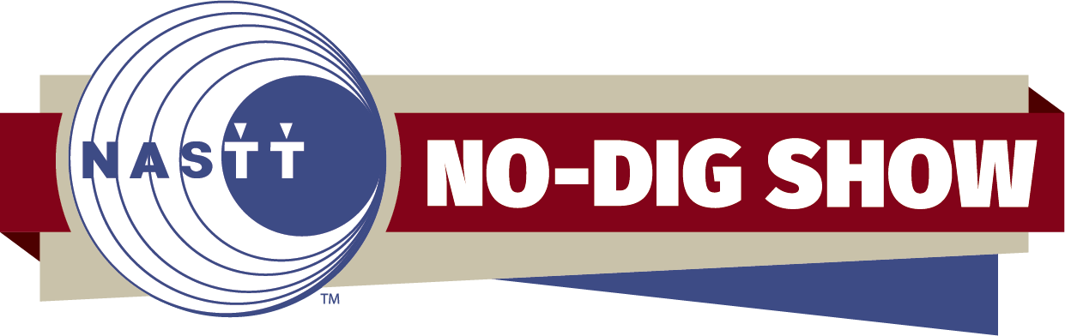

NASTT No-Dig Show Paper Review Checklist

- Housekeeping / General Items
_____ Is the paper on the correct No-Dig Show template?
_____ Does the information on the paper match the information in the system (title, authors)?
_____ Does this paper show any indications of commercialism?
_____ Is the grammar acceptable?
_____ Is the writing clear and to the point?
_____ Are the graphics clear and easily read?
_____ Is the paper length appropriate? Typically papers are 6-10 pages.

- Abstract
_____ Is the abstract a brief description of what is contained in the paper?
_____ Is the abstract the same or very similar to what was submitted to the committee?

- Introduction
_____ Does the introduction explain the setting or background of the paper?
_____ Does the introduction set the stage for the body of the paper?

- Body
_____ Does the body of the paper tell the story?
_____ Is the body broken into several subsections? Examples below:
- Design, Goetechnical Conditions, Contracting, Construction, Challenges/Lessons Learned
- Hypothesis, Testing Mechanisms/Research Studies, Results, Analysis
- Description of Method, Applicable Soil Conditions, Challenging Applications, Case Histories

- Conclusion
_____ Does the conclusion explain why the author wrote the paper?
_____ Does the conclusion explain everything clearly?

- References
_____ Does the paper have references where the content is not original?
_____ Are the references standardized?

- Red Flags (Please contact NASTT Staff if any of these statements receive a check mark)
_____ Does this paper degrade other products or accepted industry standards?
_____ Is this paper cited in any form of ongoing or pending litigation?

