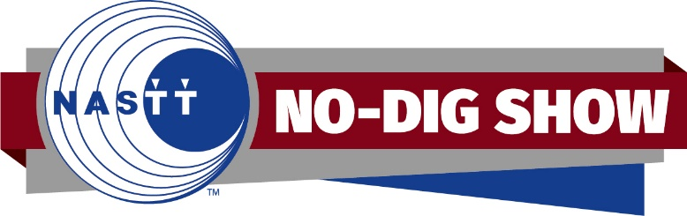

**NASTT Technical Program Committee Chair**

**Role Summary**

The Technical Program Committee Chair will provide feedback and decisions for technical program aspects of the No-Dig   
Show.

**Requirements**

The Technical Program Committee Chair must be a member of the Technical Program Committee during the two years prior to serving as the Chair. After serving as the Technical Program Committee Chair, this position will serve as the Planning Committee Chair.

**Key Responsibilities**

* Meet with the NASTT Conference Program Specialist
  + February: Review abstract call system and suggest any updates or changes.
  + May: Review committee processes and suggest any updates or changes.
  + July: Review committee scores.
  + November: Assist in building the technical paper schedule.
* Host Committee Meetings
  + July/August: Host virtual Technical Program Committee meeting.
  + January: Host virtual Technical Program Committee meeting (if needed).
* Host Technical Forum
  + November: Confirm topics with the NASTT Conference Program Specialist
  + January: Confirm participants and schedule a meeting to discuss canned questions.
  + February: Create PowerPoint presentation.
* Fill Paper Drops
  + November-March: Be available via email to suggest standby abstracts to fill any drops in the schedule.
* Serve on Planning Committee
  + July: Attend in person Planning Committee meeting in next year’s conference city.
  + August-March: Serve as a liaison between the Technical Program Committee and the Planning Committee.

**What You’ll Bring to the Role:**

* An active membership with NASTT in good standing
* A minimum of two years of experience on the Technical Program Committee.
* The ability to meet deadlines and deliver tasks, specifically feedback on replacement abstracts, in a timely manner.

**How to apply**

To apply, complete the brief online application to include the upload of your resume and a cover letter by the deadline.