North American Society for Trenchless Technology (NASTT)
2026 No-Dig North
Calgary, Alberta
November 2-4, 2026
WA-T4-03
PRESERVING CASPER’S INFRASTRUCTURE: A LARGE-DIAMETER TRENCHLESS PIPELNE REHABILIATION PROJECT
Mark G. Wade, P.E., BlueWater Solutions Group, Inc., Lawrence, KS, USA, (785) 550-9022, mwade@bluewatersolutionsgroup.com
- Abstract
This paper presents a project overview to rehabilitate a deteriorating large-diameter wastewater interceptor sewer using trenchless cured-in-place pipe (CIPP) for the City of Casper, WY. This project restored critical portions of the City’s main wastewater interceptor system for the next 100 years. The pipeline, known as the North Platte Sanitary Sewer Interceptor (NPSSI), represents a nine-mile conveyance system that was initially constructed in early 1980s. Since that time, the pipeline deteriorated due to the presence of elevated levels of atmospheric hydrogen sulfide (H2S). The project team that studied, designed, and provided construction observations services over a 5-year period included CEPI, BlueWater Solutions Group, and Jacobs. The contractor for this $6.7M project was Aegion/Insituform (now Insituform/Azuria Water Solutions Company). Construction of the most critical portions of the NPSSI began in mid-2022 and was completed in early 2023. It included 7,600 ft (3,600 m) of 48-54 in (1,220-1,380 mm) pipe rehabilitation along with numerous point repairs, new junction structures, and improved river siphons and inlet/outlet structures. Despite record winter weather conditions and numerous site challenges that were encountered, the project was completed on time and within budget. The NPSSI project demonstrates that the successful renewal of a large-diameter wastewater interceptor within a stream-sensitive aquafer can be done using trenchless renewal in the best way possible.
KEYWORDS: trenchless, rehabilitation, CIPP, large, diameter, wastewater
- BACKGROUND OF THE NORTH PLATTE SANITARY SEWER INTERCEPOTOR SYSTEM
The City of Casper owns and operates the NPSSI (nine miles in length) as shown in shown in Figure 1.

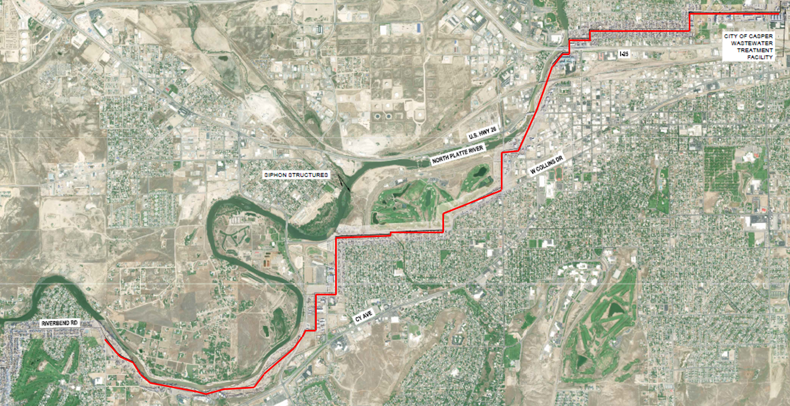

Fig. 1. Approximate Location of the NPSSI

The NPSSI was designed and constructed from 1980 to 1983 in four phases as part of a wastewater regionalization effort in the Casper Metropolitan Service Area. The pipe material for the interceptor is unlined reinforced concrete pipe (RCP). Due to slower-than-expected growth rates during the past 40 years, the NPSSI remained (and still remains) oversized for current and projected flows. Consequently, daily wastewater flow rates through the NPSSI resulted in lower-than-anticipated velocities and elevated levels of hydrogen sulfide (H2S) in both the ambient air (head) space within the NPSSI with the highest concentrations in the lower/downstream portions of the system. As such, the H2S and associated sulfuric acid formation became problematic along the entire interceptor alignment, causing serious deterioration of the NPSSI. Examples of corrosion are shown in Figure 2.
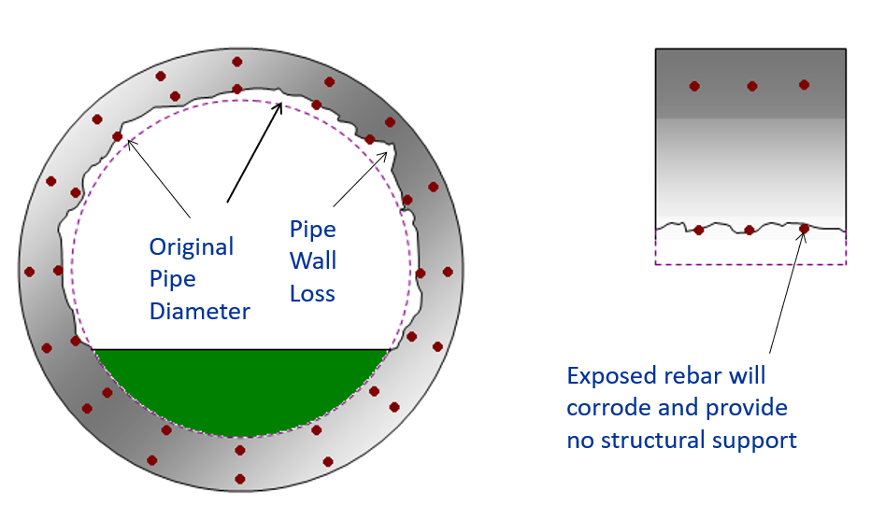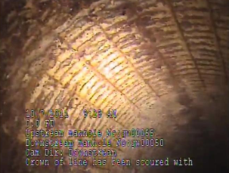

Fig. 2. Example of H2S Wall Corrosion Observed by Remote CCTV Inspection in the NPSSI
Although various corrosion control strategies and limited rehabilitation had been attempted previously, a sizable portion of the NPSSI needed immediate rehabilitation. In fact, the City and the project team had a long history in the assessment and development of solutions to extend the life of the NPSSI, dating back to 2008, when they began a series of strategic meetings to develop a two-part condition assessment of the entire NPSSI alignment. The initial assessment included detailed inspections of all 155 access structures and substantial portions of the interceptor at these access locations using remote top-side digital technologies and tools. Based on the initial inspections, the project team prioritized the interceptor segments for the more detailed end-to-end CCTV inspections. By using CCTV equipment designed specifically for large-diameter pipelines, the team selected the highest priority pipe segments (approximately 25% of the NPSSI) for more advanced inspections as part of a second phase of investigation and assessment. Following this second phase of inspection, a higher level assessment was conducted that involved the measurement of wall loss and the development of a risk-based model to determine scores for both likelihood and consequence of potential and sudden failures over the next twenty years. The engineering team completed a condition assessment report, which was submitted to the City in 2012.

Full scale pilot testing of corrosion control chemicals immediately began in the summer of 2012 and continued through 2013. Corrosion controls were determined to be cost effective at that time and it deferred more expensive structural renewal of critical sections for a few more years. It also provided the City time to adopt a long-term capital improvement strategy (as opposed to unplanned and reactive emergency repairs). With this strategy in place, the project team continued to evaluate the highest-priority pipelines that required immediate replacement and/or rehabilitation. Rehabilitation methods were evaluated to determine the best-fit solutions for what would become a complex project. The project engineering team identified several key project issues based on their insights from their earlier and updated investigations. In summary, the following were considered these key issues that would result in a successful completion of the project:
- Maintain interceptor capacity during construction and mitigation plans for potential pipe failure;
- Minimize traffic impacts and disruption and identify staging area locations;
- Implement initiative-taking public outreach and notifications;
- Identify contractor scheduling constraints and cost impacts;
- Minimize wastewater treatment plant impacts from pre-rehabilitation cleaning;
- Refine scope and bidding strategies to meet budget.

The team then developed a strategic Design Memorandum that outlined those trenchless rehabilitation technologies determined to meet these project requirements. Once approved the project then advanced to the development of a comprehensive set of plans, specifications, and bid documents to meet those requirements and strategic goals and released a final bid package in February, 2022. This bid package allowed potential contractors to select either (a) sliplining or (b) CIPP rehabilitation as “or-equal” options. Following the pre-bid and bidding phases, the project was finally awarded to Insituform/Aegion in the fall of 2022 as the lowest, responsive and responsible bidder. Construction starts shortly thereafter. The method of rehabilitation chosen by Insituform in their bid was CIPP.
- PROJECT DESCRIPTION FOR REHABILITAITON OF THE NPSSI USING CIPP
The Project scope consisted of selected alignments for rehabilitation of the NPSSI RCP interceptor 6,675 ft (2,035 m) of 48 in (1,220 mm) and 885 ft (270 m) of 54 in (1,380 mm), including point repairs, (24) 72 in (1,830 mm) and 84 in (2,135 mm) doghouse manhole construction with depths of 8-16 ft (2.4-4.8 m), abandonment of (15) manholes, epoxy lining of (10) existing manholes, and rehabilitation of two siphon inlet and outlet structures. Following initial meetings and discussions between the project team and Insituform, it was determined that the challenges would be winter weather, the volume of debris inside the pipe and the erosion of the RCP pipe down to the rebar ribbing making man entry unsafe. Therefore, the 48 in (1,220 mm) and 54 in (1,380 mm) CIPP was separated into two phases (Alpha and Beta Phases) for bypass pumping to create efficiencies for the participating subcontractors, and to strategically place a break in the work activities during expected colder periods of weather. The Alpha Phase project is shown in Figure 3. The Beta Phase was further upstream and similar in size and magnitude to the Alphas Phase.
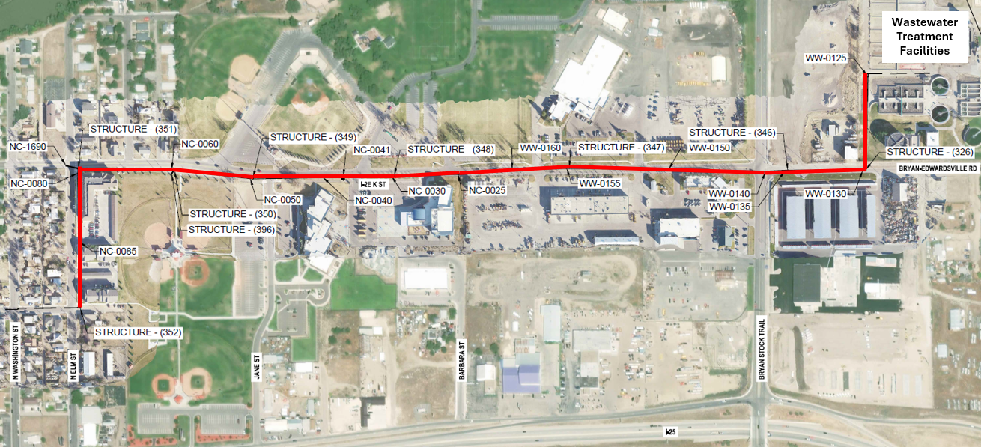

Fig. 3. Location of NPSSI CIPP Project – Alpha Phase
The pre-cleaning and follow-up rehabilitation of the NSPPI began quickly, in order to (a) prepare, (b) wet-out at Insituform’s facilities south of Salt Lake City, (c) transport, and (d) install the CIPP system. This was a herculean effort, considering the size of the project, time of year (winter approaching) and distance between the wet-out facilities in South Utah and the job site.

Precleaning of the NPSSI system targeted for CIPP rehabilitation was also challenging as it presented two serious issues: the pipeline was severely corroded (in many places, reinforcement of the RCP was either exposed or gone as shown in Figure 2) and the amount of debris on the bottom of the pipe was significant. Initial cleaning of the interceptor was attempted with “spinning nozzle” scouring equipment. However, as it moved through the pipeline, it was unable to complete the work due to the sheer amount of sediment in the pipe. Several attempts were made to modify the frame of the spinning nozzles and roller wheels above the water line. However, these modifications proved to be ineffective. After a coordinated effort between the project engineering team and the cleaning subcontractor for Insituform, a uniquely designed “floating scouring” nozzle and platform was developed and implemented. The reconstructed nozzle was deployed on a pontoon raft and floated down the line segments scheduled for inspection. Figure 4 shows this system as it was transversing through the NPSSI in a downstream manner between access structures.

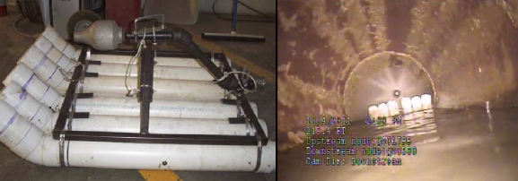

Fig. 4. Cleaning/Pipe Scour System Inside NSPPI

Once a segment of the NPSSI was pre-cleaned and inspected using a remote CCTV platform designed for large-diameter pipelines, Insituform’s subcontractor, Xylem, then mobilized and installed a temporary bypass system that allowed the CIPP installation work to be done within the pipeline in the absence of wastewater flow. The site of an example bypass system is shown in Figure 5.

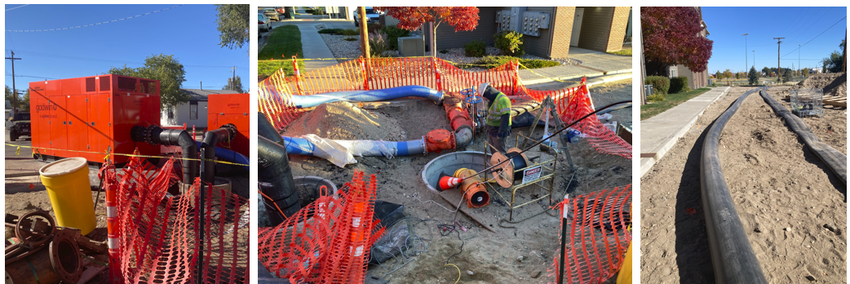

Fig. 5. Typical Temporary Bypass System during CIPP Installation

Once the bypass system was in place and the pipeline ready for rehabilitation, the Insituform installation team mobilized and work began sequentially, beginning and at the furthest downstream location. A typical installation followed the sequencing below:

- Initial notifications to local residents, the City’s Public Works Department (traffic, water, wastewater, engineering, administration, and PR office);
- Final CCTV inspection and documentation, end-to-end;
- On-site set-up of traffic/pedestrian controls, CIPP installation systems, boiler check, and final CIPP liner checks and coupon extractions;
- Installation of CIPP and CCTV monitoring;
- Steam cure-out;
- Line reinstatement;
- Post-CCTV Inspection;
- Extraction of additional cured-CIPP liner;
- Active flow reinstatement for all active services and lateral connections.

In general, a full installation and service reinstatement took approximately 18 hours. As with most construction of major public utilities, issues arose during these first few installations that required some changes and modifications as the project progressed. However, the Alpha Phase work was completed within the project schedule and budget with only few change orders issued, reviewed, and approved by the project team and the City. At the onset of winter, work under the next Beta Phase was more weather-dependent and required some scheduling push-back from time to time. The advantage of the use of CIPP for pipeline rehabilitation is that it can tolerate lengthy delays between the time it is impregnated with resin and the time it is installed (up to 30 days, in general). Also, the product is more suitable and easier to manage under colder climates and environments.

An example of an actual insertion (and inversion) of a 48 in (1,220 mm) CIPP liner from the backend of the transport truck, through the installation system, and into the receiving end of the interceptor is shown in Figure 6.

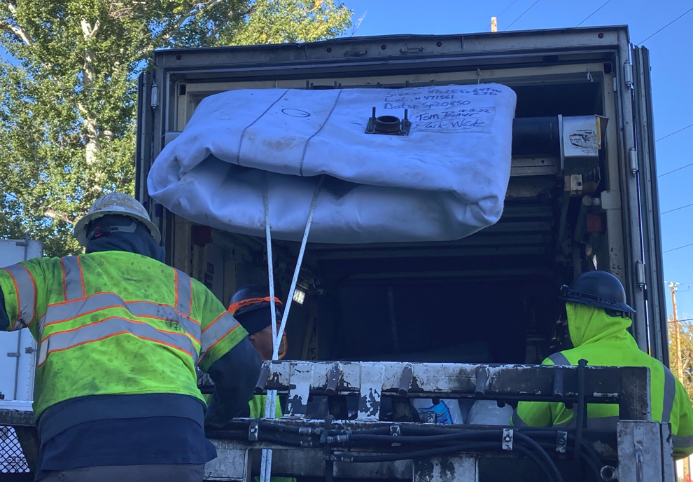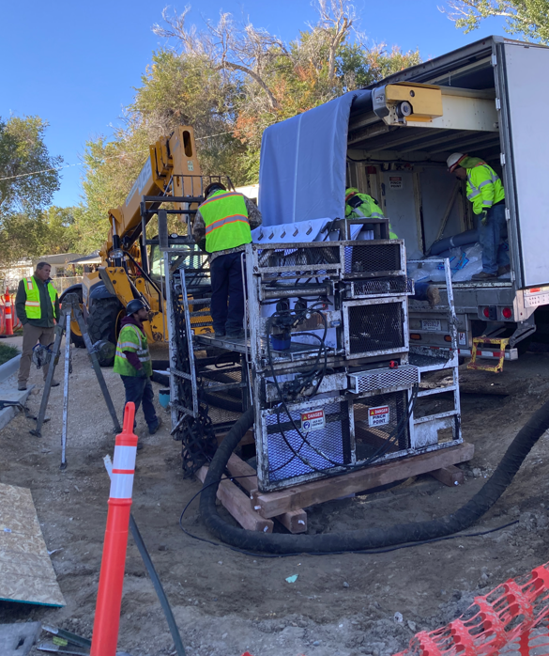

Fig. 6. Example CIPP Installation of 48” Liner

Once the CIPP system was installed, the next phase of the project for both Alpha and Beta Phases that needed to be tackled was the rehabilitation of the fifteen (15) existing access structures (some as large as 7.0 ft (2.13 m) in diameter. Under the project team’s technical specifications, there was a wide range of options available to Insituform and the subcontractor, depending on the location of the access structure and extent of corrosion of the existing precast or brick structure. The available rehabilitation options were as follows (some options that might require a combination):

- Poured-in-place Liners;
- Cementitious Relining;
- Epoxy Relining;
- Chemical Pressure Grouting.

As part of the work, all structures required extensive reconstruction to the bench and invert of each location. Figure 7 shows typical work associated with the renewal of these access structures.

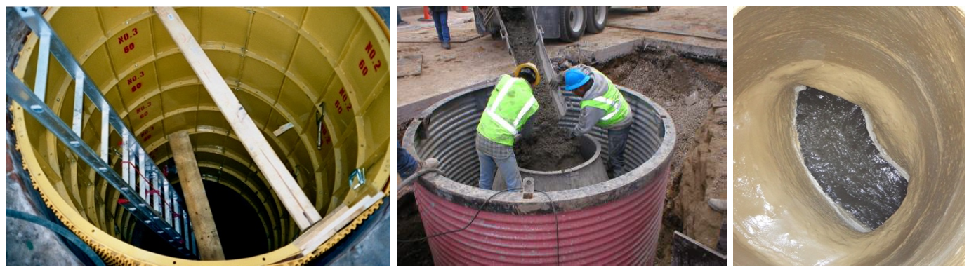

Fig. 7. Example Rehabilitation/Reconstruction of Access Structures

Construction rarely takes a break in the winter in Wyoming. Consequently, the rehabilitation work associated with the Beta Phase began in mid-December and continued through mid-March. Daytime elevated temperatures rarely got above 10 degrees F (-12 C). Work associated with inspection, cleaning, and CIPP lining slowed significantly. In fact, one of the installations included a 24-hour period when temperatures reached -30 degrees F (-35 C). A cold-weather site set-up is shown in Figure 8.

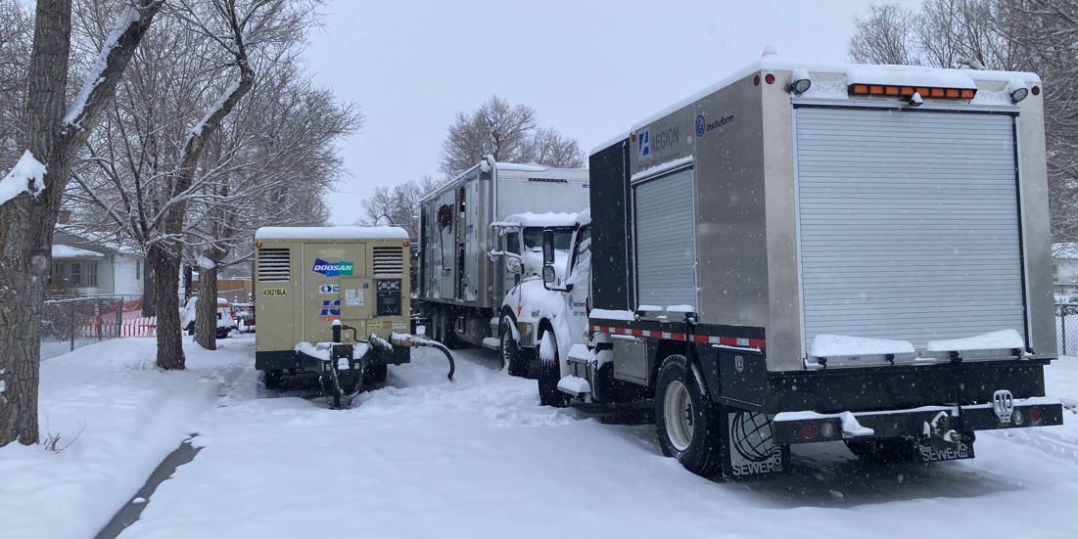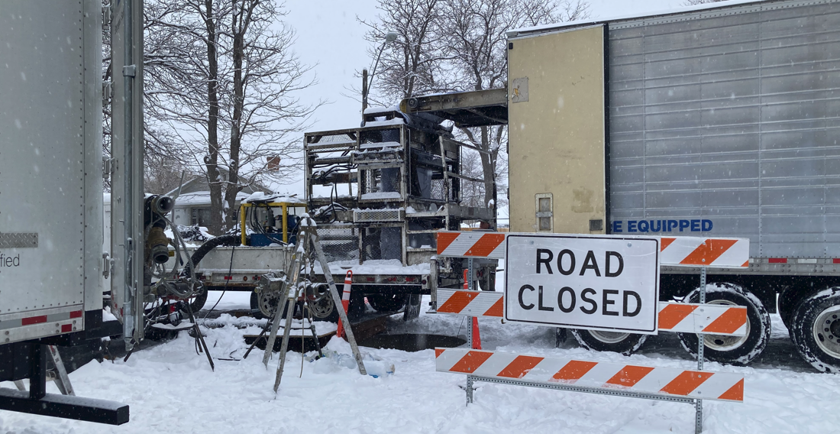

Fig. 8. CIPP Installations During Winter Example CIPP Installation of 48 in (1,200 mm) Liner
- INNOVATIONS AND UNIQUE APPLICATIONS DUE TO UNKNOWN CIRCUMSTANCES
The project also included some unique challenges that required some out-of-box thinking and design modifications to accommodate site conditions that were discovered as part of the pre-construction inspection work. There were several, but two of these challenges and solutions are described as follows:

Challenge #1 – Cleaning and CCTV inspection identified a previously unknown diameter change inside the pipe from 48 in (1,200 mm) to 54 in (1,370 mm) approximately 20 ft (6 m) upstream between two access structures. Rather than installing a new structure where the diameter transition occurred, Insituform designed, manufactured, and installed a transitional CIPP liner to span the diameter change. The CIPP with a thickness of 22.5 mm was installed from the 48 in (1,200 mm) diameter end. Insituform manufactured a thickness/diameter transition and increased the CIPP liner thickness by adding 6 mm for the last 70 ft (21 m), or 22.5 mm to 28.5 mm, to accommodate the strength required to span this 54 in (1,370 mm) diameter CIPP liner. Figure 9 shows this site and the CIPP liner being installed and spanning this transition. Post-CCTV inspections showed a remarkably successful relining effort, thus avoiding the construction of a new $15,000 access structure.
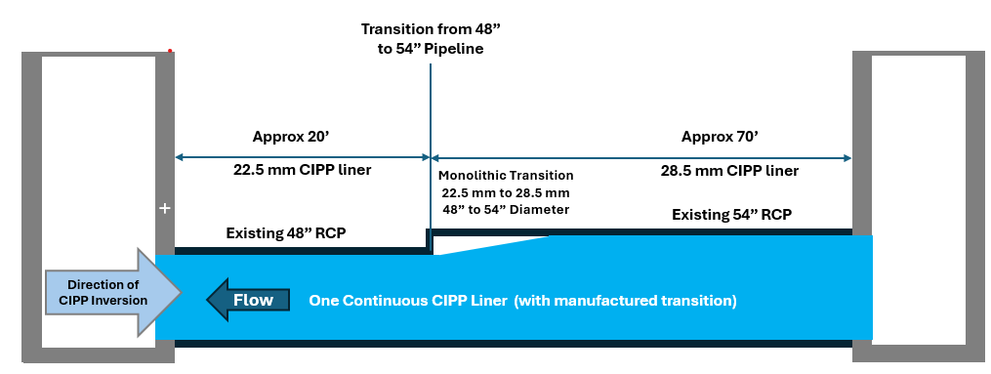

Fig. 9. Monolithic CIPP Liner with 48” (22.5mm) to 54” (28.5 mm) Transition

Challenge #2 - A utility conflict was encountered inside an access structure that included a 27 in (685 mm) stainless steel pipe installed through the middle of the vault structure leaving only a 30 in (760 mm) clearance. Consequently, there was not enough access to install the proposed 48 in (1,220 mm) diameter CIPP liner. Insituform engineered a creative solution to rehabilitate both wastewater pipelines and keep them in service. The 27 in (685 mm) pipeline was taken out of service with bypass pumping tied into the existing bypass that was set up and in service at the time. This provided the required room to install the 48 in (1,220 mm) diameter CIPP segment. Figure 10 shows this conflict in elevation between the 27 in (685 mm) pipeline and 48 in (1,200 mm) pipeline.

Insituform’s internal applications engineer updated their internal structural calculations that were reviewed by the project team for the 27 in (685 mm) CIPP and concluded that there were no issues or concerns with spanning the 6 ft (1.8 m) vault structure. Deadload designs were approved, as well. The 27 in (685 mm) diameter pipe was then restrained and tied off to the 48 in (1,220 mm) CIPP installation using appropriate fittings and then CIPP was installed through the 27 in (685 mm) pipe section. Historically, the 27 in (685 mm) diameter pipe had experienced periods of maximum capacity flows. Consequently, Insituform recommended cutting two circular openings at two locations of the spanned pipe at the 10 o’clock and 2 o’clock positions. The purpose of the four openings was to allow overflow, during high flow periods to be redirected from the 27 in (685 mm) pipe to the 48 in (1,220 mm) pipe within the existing vault. The excavation subcontractor placed concrete in the bottom of the structure to provide additional structural integrity and the entire structure was spray-lined and put back into full service after bypass was shut down.

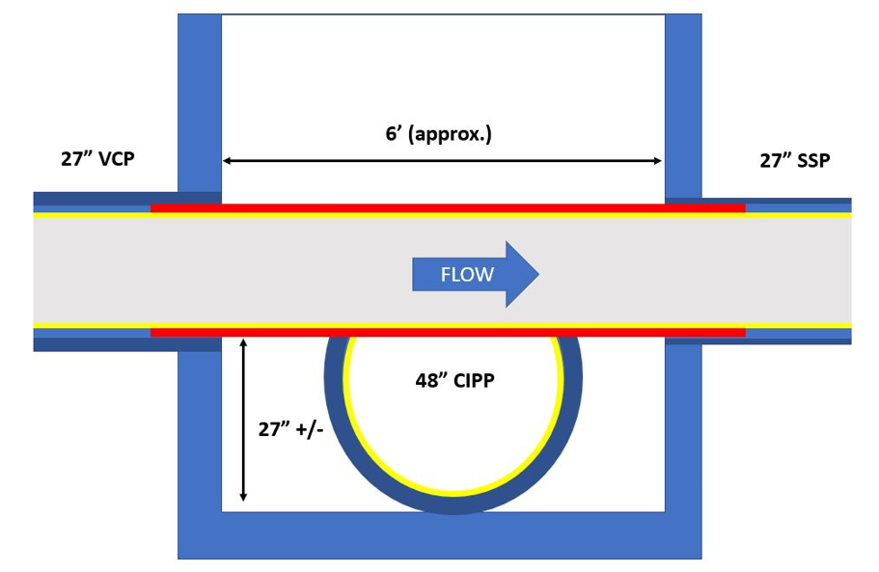

Fig. 10. Elevated Transitional CIPP Installation

Other challenges that were encountered as well are briefly described as follows:

Senior Residential Housing Near Construction Zone - One particular street intersection location required excavation and CIPP installation within 10 ft (3 m) of the front door of the Legacy Senior Residential Complex. Keeping the public safe from work activities was certainly challenging because the residents were quite curious about the work near the front entrance of the facility. Insituform’s CIPP crew took the time to talk with each and every resident about the process and why the work was being done. In fact, one resident was so impressed that she purchased Subway® sandwiches for the contractor’s crew as a way of saying “thank you” for their hard and conscientious work. Word of the crew’s efforts made its way to City officials who were greatly impressed and an article about the project was published in the local newspaper! All this happened in the dead of winter.

Construction During Extreme Winter Weather Conditions - Extended CIPP cure times were extremely hard on workers and equipment and additional safety precautions needed to be planned out ahead of the work being done from mid-December to mid-February.

Siphon Structure Rehabilitation – The removal and replacement of several slide gates added to the challenge of maintaining a “minimal-dig” project. This included care design and engineered solutions for the placement of concrete, spray-lining, and constructed access to the location of these gates.

Public Safety – Some sections of pipe were in locations of residential, commercial, and parks and recreational areas. Working around closures of streets for public events was carefully planned to keep the public safe. Notifications to stakeholders occurred early in the project and throughout the duration of the project to keep everyone well informed.

Change Orders and Lessons Learned – Although the goal of any construction-related project is to avoid, as much as possible, change orders that can increase the cost of the project and/or delay the completion of it, these are a particular challenge for buried infrastructure such as severely deteriorated large-diameter wastewater interceptors. In the case of the NPSSI rehabilitation project, there were a total of nineteen (19) project-related field changes that were reviewed, approved, and bundled into six formal COs submittals for payment. Using a combination of Debit COs and Credit COs, it kept the overall cost of the six COs below a certain City-imposed financial and project budget thresholds in check. Ultimately, this allowed for faster approval by the City and their project team and kept the project moving forward, thereby maintaining the overall schedule and deadlines.

Lessons learned from the Casper NPSSI, in looking back over the 8 years when the project was initially conceived, and funding approved for the initial study and investigation work are as follows:

- Don’t skimp on the costs associated with a full and comprehensive internal inspection and assessment regardless of its cost or imposition to the operation of a critical system such as large-diameter wastewater interceptor;

- Bring together those groups that are heavily invested in such critical buried infrastructure (engineering, planning, management, operations/maintenance, financial experts, users, transportation departments, county/state/federal regulators, local news outlets, and peer groups);

- Allocate enough funds during the design phase to cover additional geotechnical costs;

- Spend time reviewing ALL historical records and documents. Perhaps identify and schedule breakfast or lunch with past retirees who have working knowledge of the pipeline and its history;

- Always assume that if there’s a potential conflict with other utilities, there probably is so don’t skimp on upfront SUE work, despite the intended goal to rehabilitate the interceptor with “trenchless technologies;”

- Make sure the bid schedule is thorough and complete;
- SUmmary and Conclusion
Despite severe winter weather conditions, the time involved for value engineering, and all the site challenges encountered, the project team and Insituform Technologies successfully completed the project for the City of Casper with only one time extension (and this due to winter asphalt paving conditions). Better yet, the total cost of the project at its conclusion was $10,000 under the original contracted amount. The NPSSI rehabilitation project exemplifies the successful execution of a critical infrastructure initiative under severe winter conditions. This comprehensive project demonstrates the importance of understanding the history of a system, collaboration by all stakeholders, careful planning, and executing innovative technologies to achieve an outcome beyond expectation. This section of the NPSSI is now ready for reliable conveyance of wastewater to the City’s WWTP for the next 100 years!
As an added note, this project was awarded the Rocky Mountain North American Society of Trenchless Technology (RMNASTT) Project of the Year Award in 2023.
- acknowledgments
We would like to acknowledge Leanne Goodhue of Insituform Technologies and Tom Brauer and Krista Johnston of the City of Casper, for their contributions to this manuscript. They are the real reason that this project was a total success including the means and methods developed and implemented to deal with the challenges that are always encountered when rehabilitating buried pipeline assets.
- References
Snider, K. and Wade, M. 2014. Sanitary Sewer Interceptor Corrosion Modeling and Corrosion Control Pilot Testing at Casper, WY. WEFTEC, New Orleans, LA. September 28, 2014.

ASTM 1216, Standard Practice for Rehabilitation of Existing Pipelines and Conduits by the Inversion and Curing of Resin-Impregnated Tube, 2019.

Jacobs Engineer, Project Plans and Specifications, “North Platte Sanitary Sewer Rehabilitation – City of Casper Public Services Department, Engineering Division, Casper, WY,” February, 2022.

